**Instructions for installing the playfield LCD on a Stern SAM system on Tron Legacy Pinball**

A close up of a stage

Description generated with high confidence

Package contents:

* 27” inch LCD
* SAM or Total Light Show Serial to USB cable with 90-degree adapter
* Raspberry Pi 3
* Raspberry Pi 3d mount
* SD card
* USB stick
* Power adapter
* Video cable
* Instructions

**ISSUES**

1. If you are using a ColorDMD and it is connected to the 12v power molex in the front right of the playfield, you cannot use this connector for the LCD. The ColorDMD causes a Group loop which will show up as a scrolling horizontal line on the mini LCD. You will need to purchase a 5v version of the LCD with harness.

**LCD Install**

1. Remove the Bulb from the backbox.
2. Use a Phillips screw driver to remove the white power mount for the florescent tube
3. 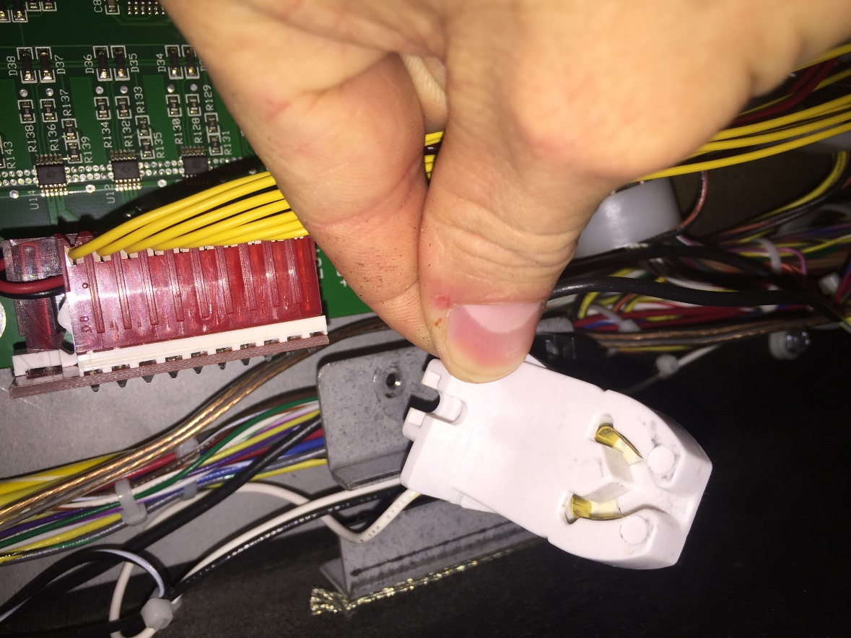
4. Tuck the white adapter behind the mount plate
5. 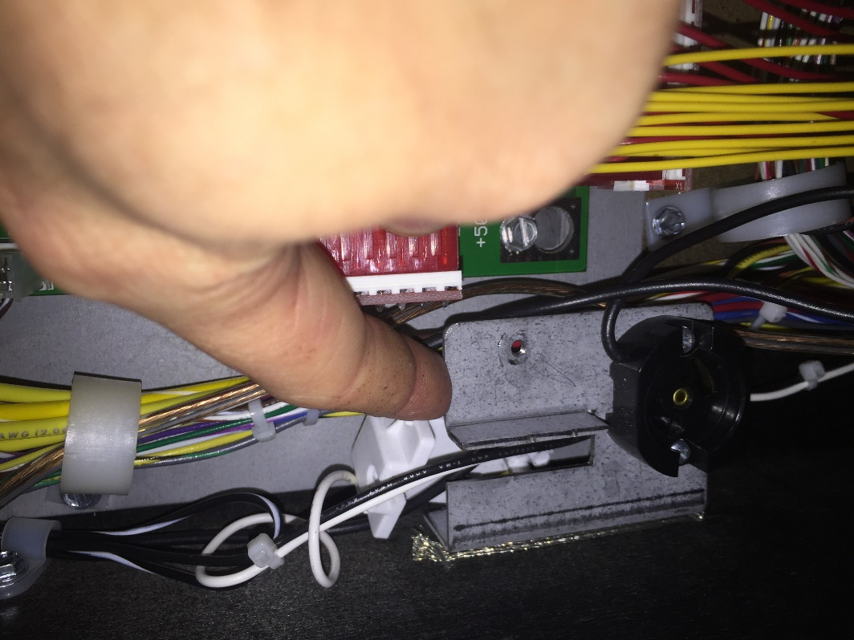
6. Install the 4” screw into the open screw hole on both sides make sure the bolt does not extend beyond where the glass goes. You want to get it far enough forward so that the LCD is close to the glass, the weather stripping will help with the light bleed.
7. 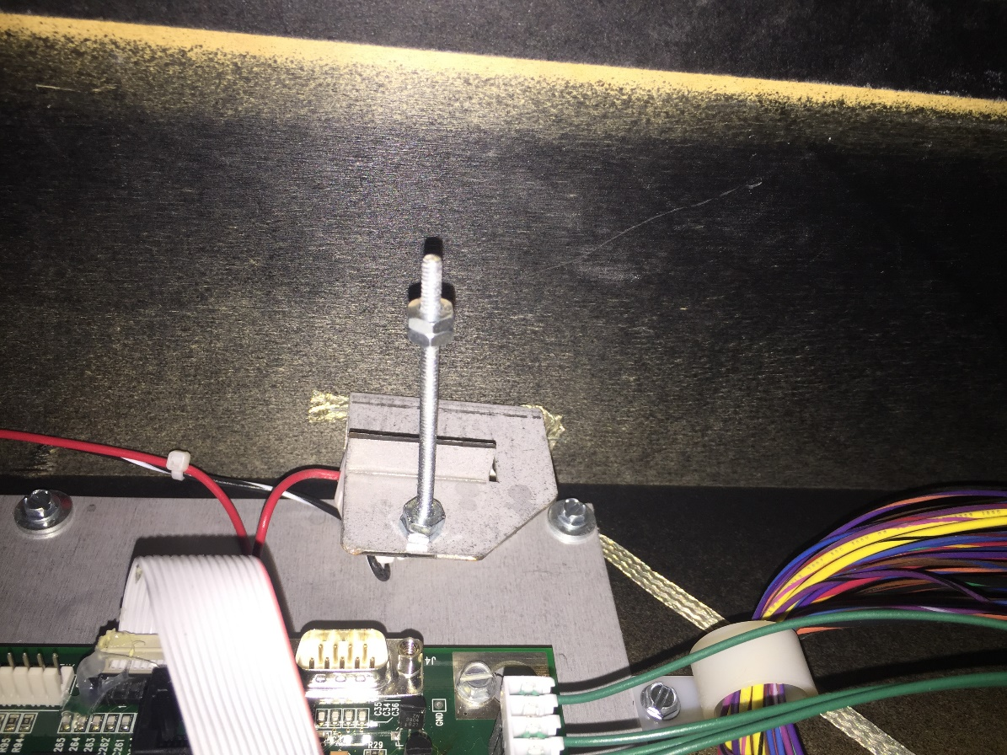
8. Install the Serial to USB interface. Plug in the 9 pin serial adapter to the Stern board (Pictured above, 9 pin male adapter) or the Total Light Show Serial interface. You may need to remove the florescent light to install the 90 degree adapter. Make sure the cable is secure and reinstall the lightbulb.
9. Install the backboard box
10. 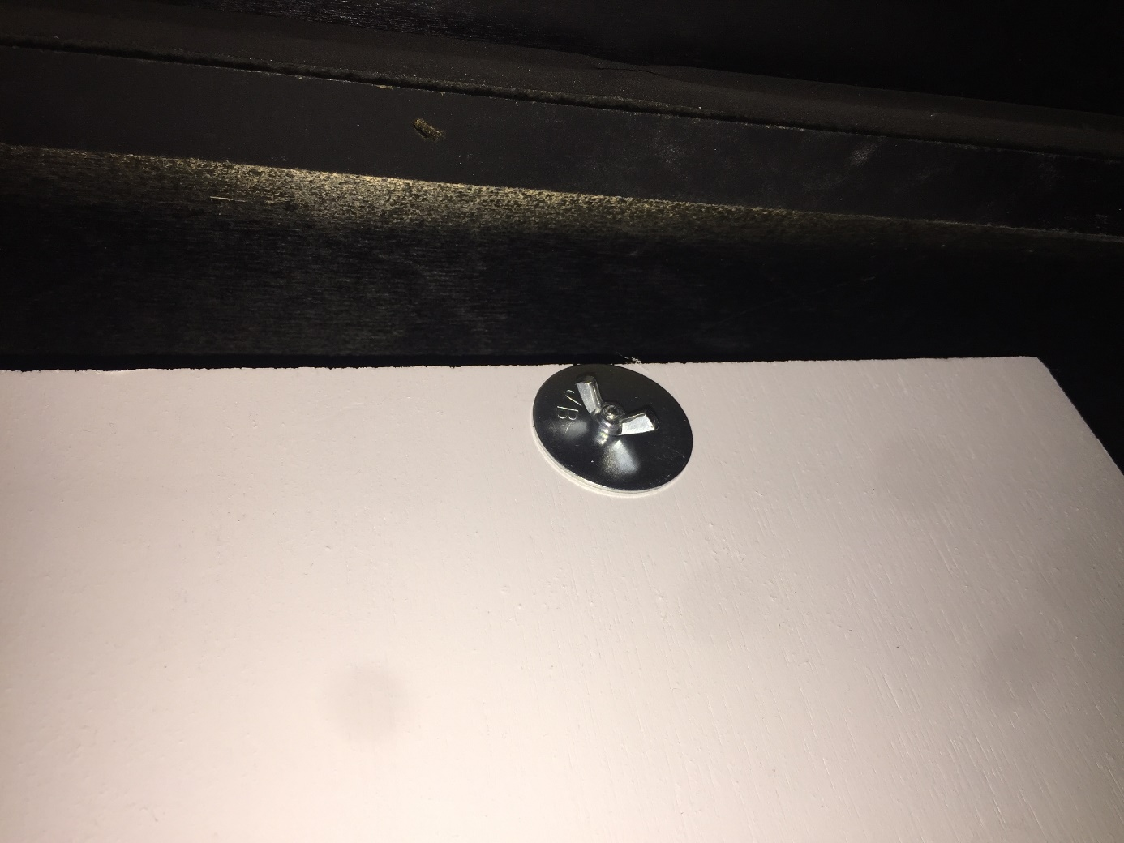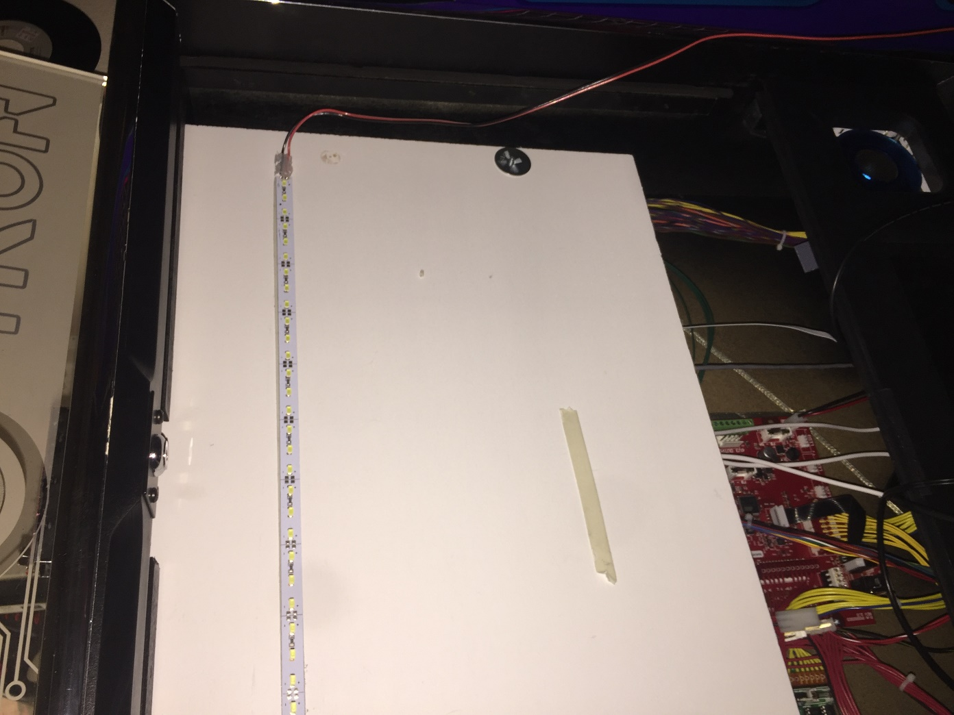
11. Install the printed grey angled parts on the existing bolts on the back of the speaker panel. This goes on each side of the DMD mount.
12. 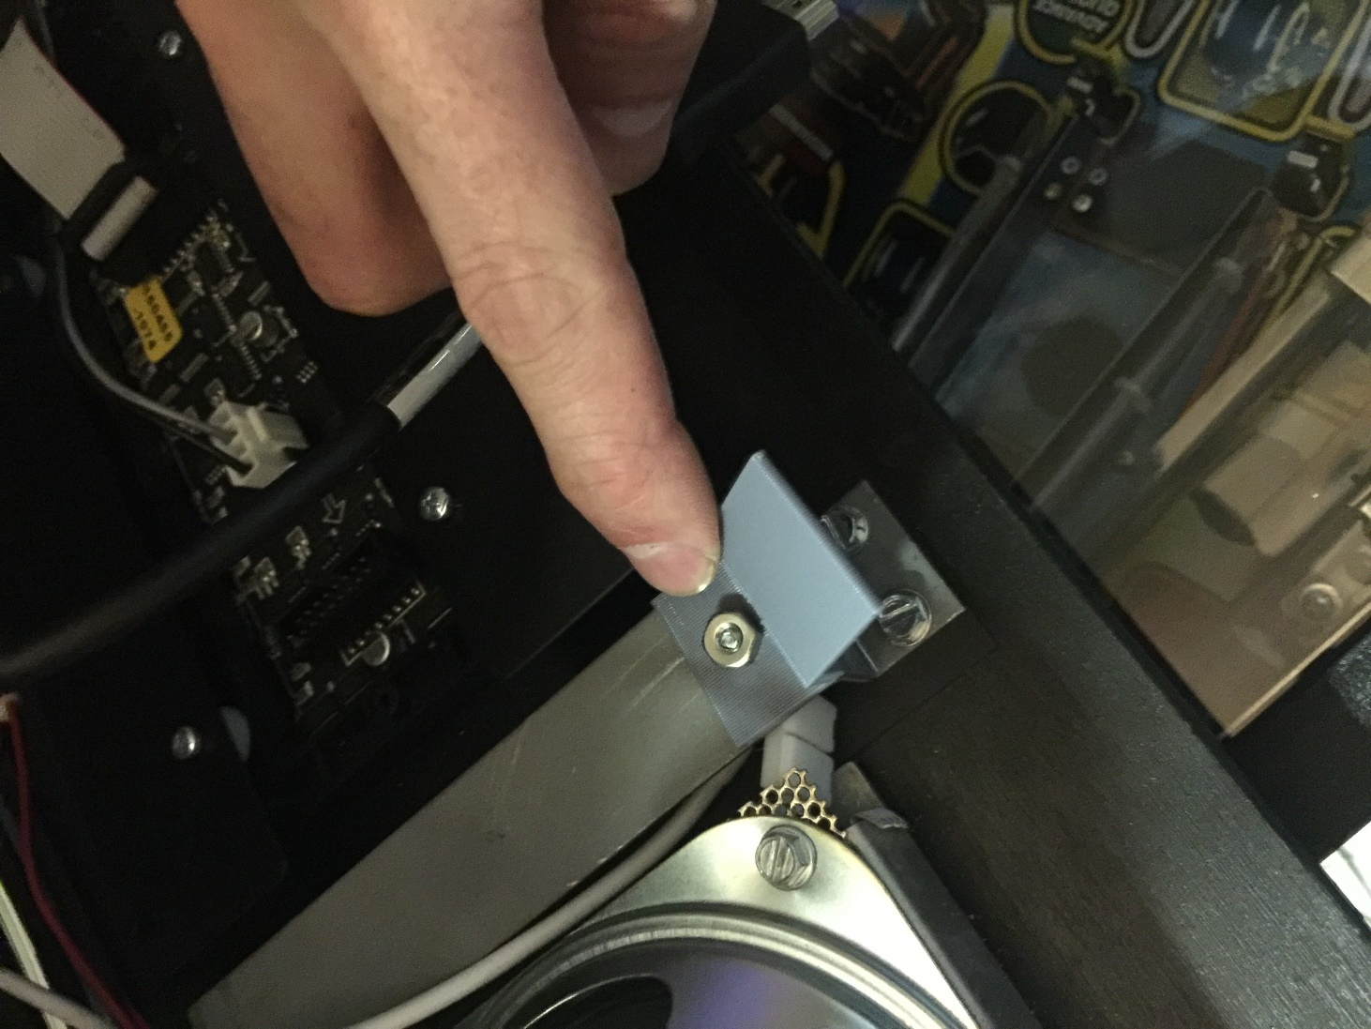
13. Re install the Speaker panel and Slide the LCD into the mounts
14. 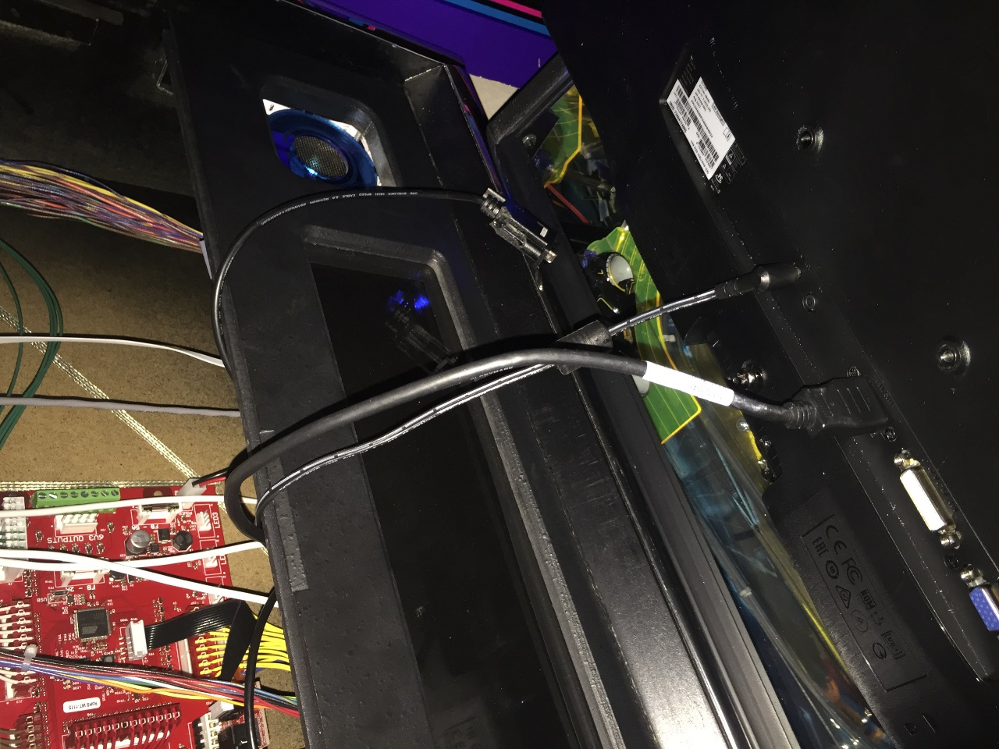
15. 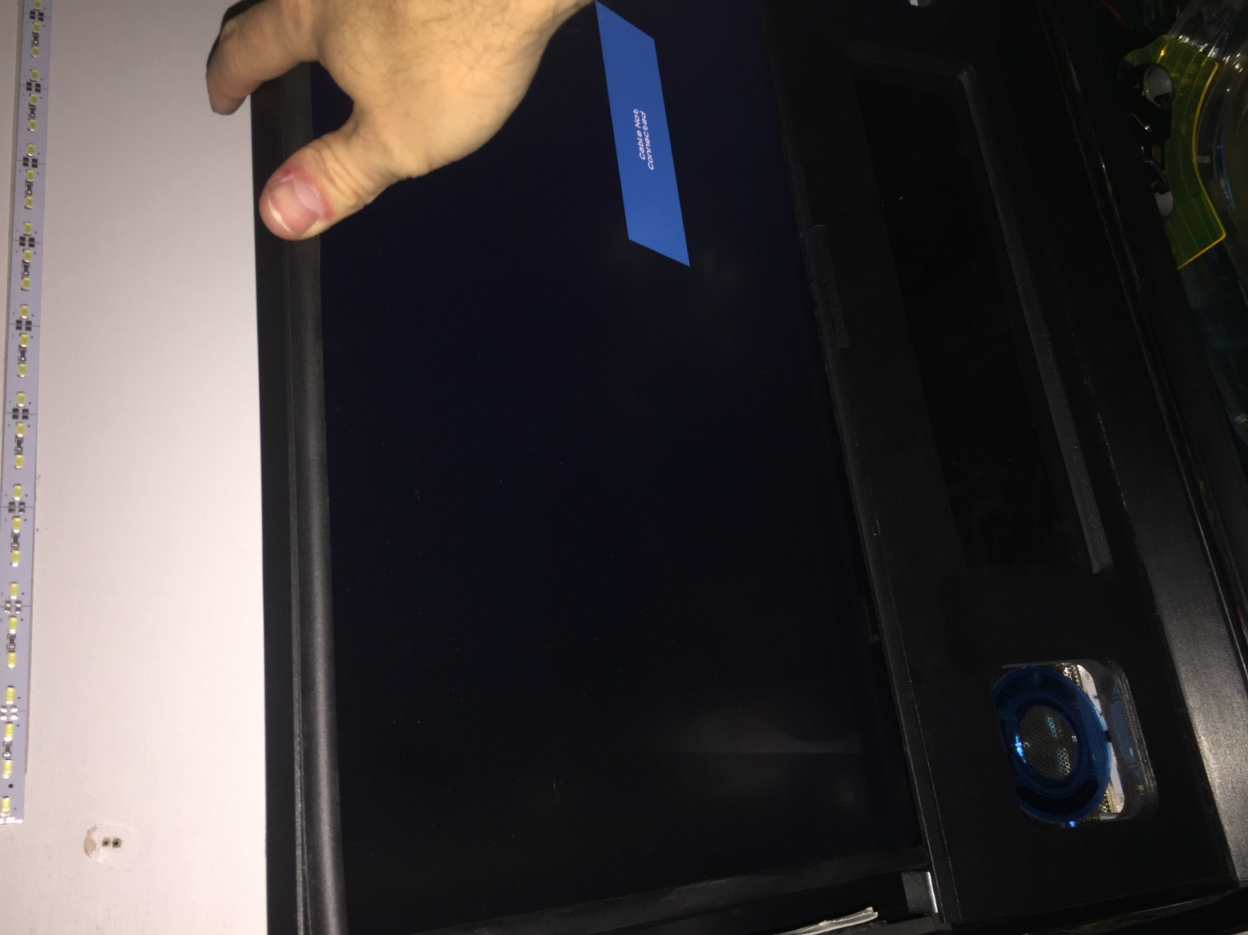
16. Install the LCD top mounts into the pre-drilled holes, you might need to tap the two wood screws into the backpanel depending on how your LCD rests in the mounts.
17. 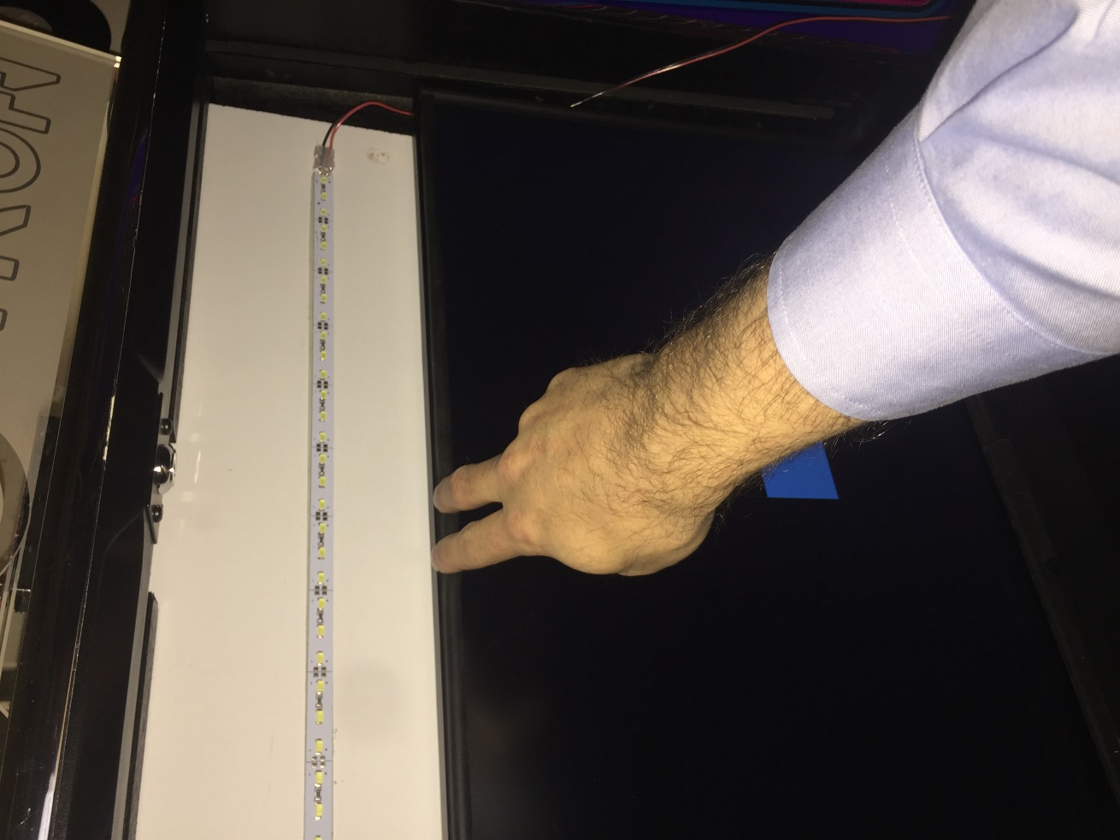
18. 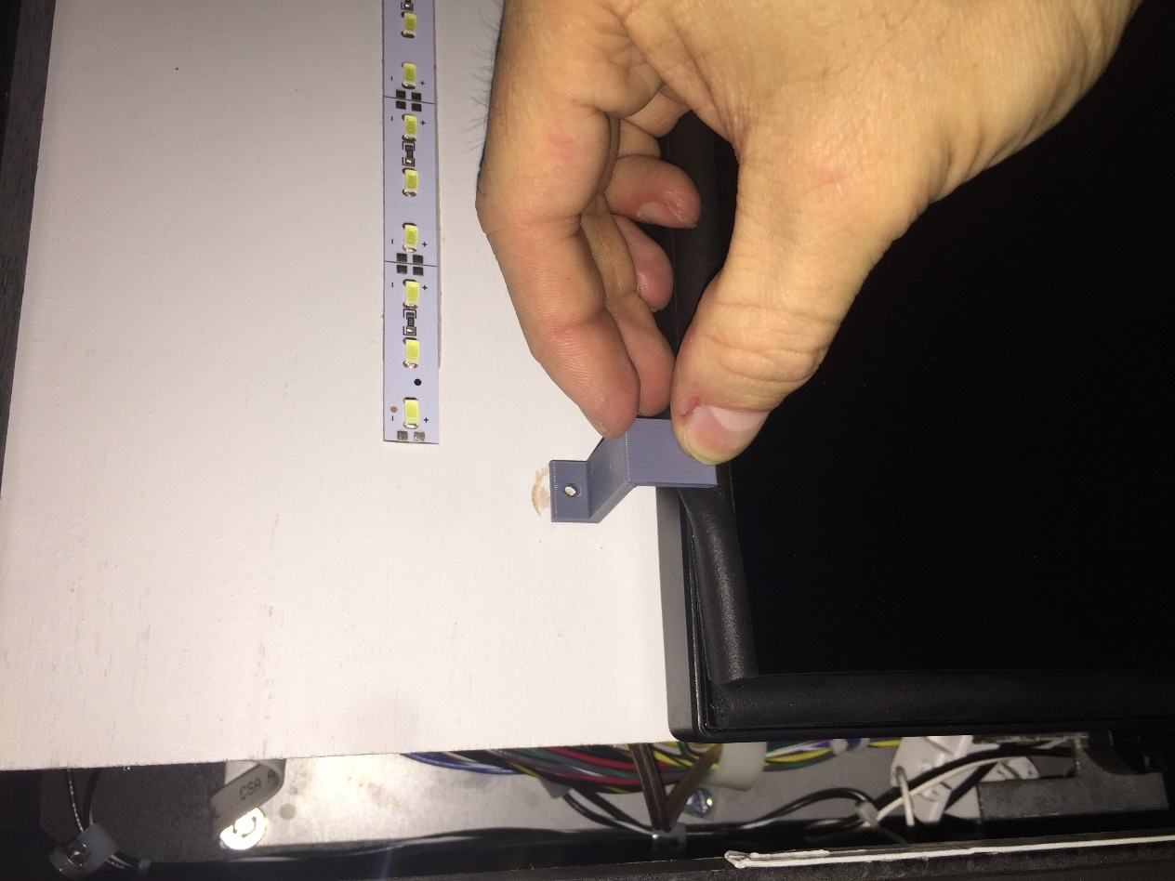
19. The HDMI for the LCD will go to the raspberrypi and the LCD power adapter will go to the 120v accessory port in the front of the machine. The LCD will auto power off if there isn’t a source and will turn on automatically when the machine comes on. If it doesn’t, reach in and press the power button on the LCD, it should turn blue.
20. Re-install the backglass with a new Translite.
21. Plug in the 3 way power adapter in the front right power connector in the front of the machine by the coin door. The splitter supports 12v and 5v. You can run the Molex adapter from the LED strip (Red and Black cable) on the backbox to the front of the machine and plug it into one port, the other port will go to the black cable with a molex on one side and a micro USB adapter on the other. You can’t mess this up, the molex adapters are wired to go to the correct power source, (12v or 5v)
22. Plug in the micro USB port to the Raspberry Pi.
23. Install Raspberry PI in backbox below the CPU board. Mounting hardware is included, or you can use an existing screw to secure it.
24. Connect the power molex to the open connector that is in the lower left of the backbox. If there is a mod already connected here, remove it and use the split connector supplied and connect both.
25. Run the power cable through cable management and over to where the Pi is mounted.
26. Install the supplied SD card.
27. Install the USB stick in one of the open USB ports on the Raspberry Pi.
28. Insert the USB cable into an open port on the Raspberry PI.
29. Remove the protective layer on the LCD by pulling the small green tab.
30. Install the black weather stripping along the outside edge of the monitor to prevent the LED strip from causing light bleed on the LCD screen.

**FIRMWARE INSTALL FOR SAM**

1. You will need to download pinball-browser to patch your TRON Firmware so that it can communicate with the LCD mod.
   1. Download pinball-browser from <http://tiny.cc/pinballbrowser6>
   2. DONATE to pinball-browser. None of this would be possible without his work and this allows for future system integrations with other Stern SAM Systems (Star Trek, Metallica, Spiderman, etc)
   3. Make sure you have the latest version of coms patch as of this writing is v132. Any version after v132 will work with TRON. This file is in the same directory as pinball-browser
   4. Open Pinball-Browser and load the Tron firmware you downloaded from Stern (v1.74)

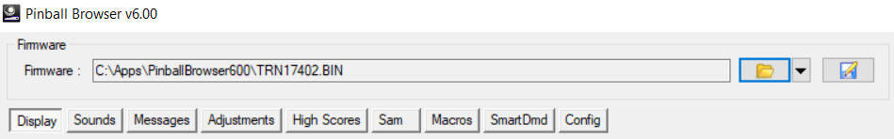

* 1. See next page:
  2. Click the “Sam” tab
  3. 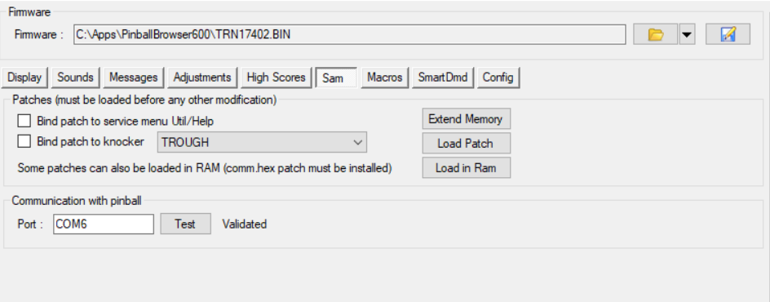
  4. Click “Load Patch” and select the comm131.hex file
  5. Enter you Tron Machine serial number in the dialog box
  6. 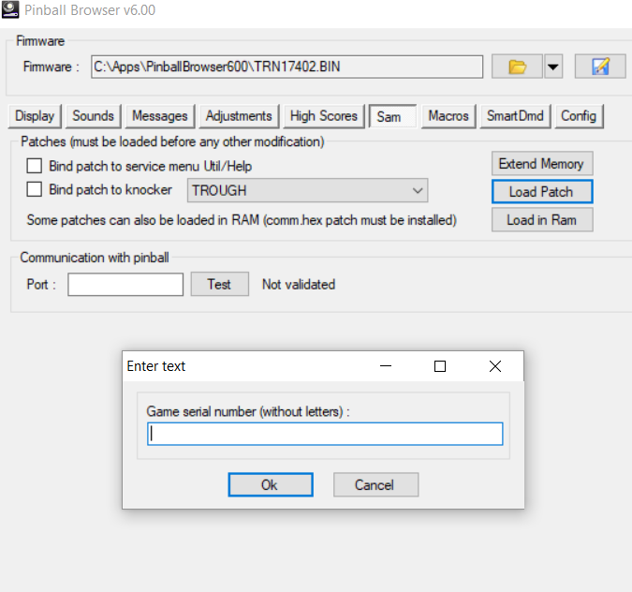
  7. Click the Save icon and Save your firmware to the root of a USB stick.
  8. 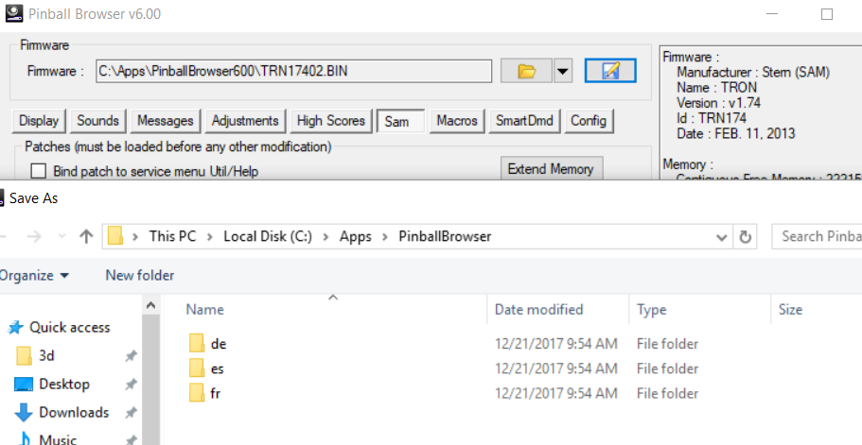
  9. Flash your Tron machine with the newly create firmware file. Follow the Stern website if you need help here: <http://www.sternpinball.com/upload/downloads/sb164.pdf>
  10. Install and boot up your new Tron Playfield LCD.

**LATEST SAM UPDATE FROM INITIAL version 1.1 to 1.4:**

To update to the latest version which contains bug fixes and enhancements:

**Installation Instructions:**

1.  You need to go download the very latest Pinball-Browser v 6.11 which will have a new comms patch of version 1.32.  You have to go re-flash your Tron firmware with this version so that I can get the new states that fix the discmb as well as some other issues.

2.  Once Patched, go here <https://1drv.ms/f/s!AnreFtnjNkJZ9ExpLVzSaawzpkdn> and download everything including the folders and copy them over to the usb stick that is plugged into the Pi.  You can just use a PC.  Make sure the folder structure stays the same and copy all the files to the usb.  The main program file is the pitron.pyc file.  You can rename your other one if you want to keep a backup copy that you can go back to. (I don't see a reason you would)

4.  **Changes to SAM version from 1.1 to 1.4:**

*  Added new DiscMB Restart mode so that detection of the mode state is possible if you don't hit the DISCMB Restart shot.

*Added DiscMB Restart Video

* Added Return to Grid Detection

*Fixed Most Active modes to clear the video list and default to The Grid video when complete

*Added structure for re-setting states on Active Multiball mode completion

* Added wait times in between mode completions to allow for video updates

*Fixed Game over video

*Added placeholder videos for SOS and Portal

*Added Portal mode detection

*updated firmware version detection to 1.32

*Turned off TRON mode for now, TRON was too busy and interrupting modes

*added debug output and log files to usb

*Prelim Ball drain detection

*Prelim Active Score per Player

**TOTAL LIGHT SHOW INTEGRATION**

1. TLS Instructions